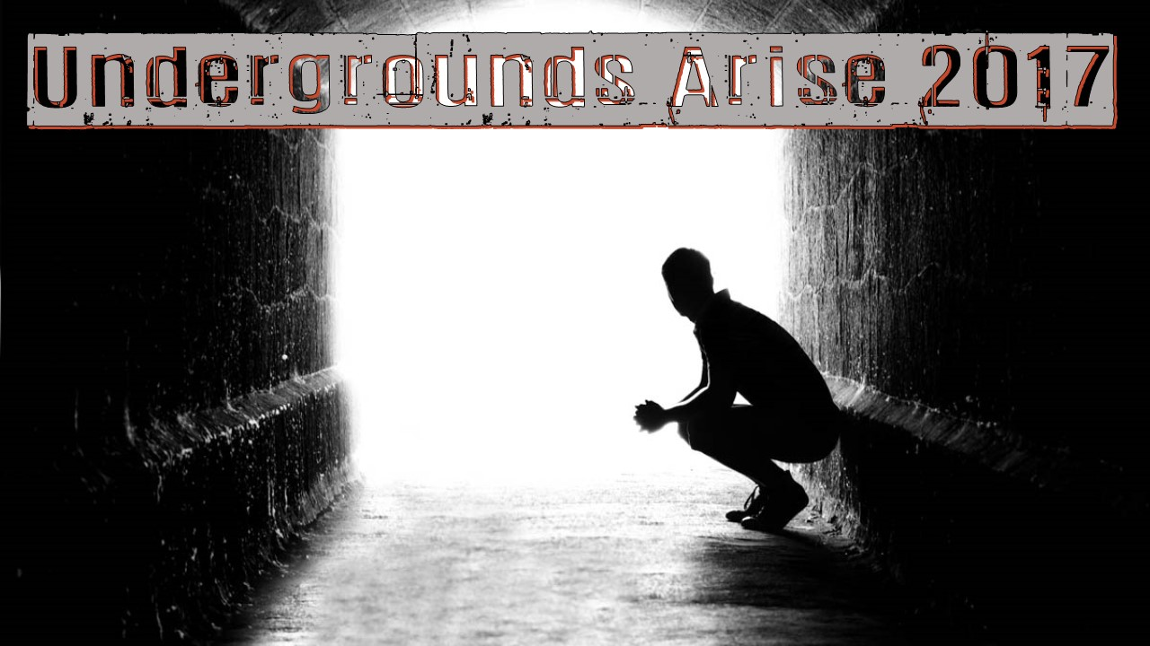

Information Packet

Event Details:
Date: March 17th @ 7:00PM to March 18th @ 11:00AM
Ages: 12-18
(Children under 12 can stay overnight with a parent/guardian)
Admission: Free
Location: 217 W Plane St. Bethel, OH 45106
Telephone: 513-427-4373
Website: faithchapeloh.org

FAQ:
Do I need to register?: To help with budgeting and planning, we would ask that you register! You can do so online at http://www.faithchapeloh.org/sign-up--contact.html or at our On-Ramp at the church.
What should I bring?: Since this is an overnight conference, we recommend you bring the appropriate items such as toothbrush, pajamas, blanket, pillow, change of clothes, brush, deodorant, etc. If you want to bring your own inflatable mattress, you are welcome to since bunking is not available.
Additionally, there will likely be free time so you may bring cards, board games, etc. Anything brought in is subject to approval of Leadership.
Will I be able to shower?: Unfortunately no. Since this is just an overnighter, we recommend some dry shampoo or a hat.
Will you feed me?: We will feed any youth staying overnight. Food will be served after service and breakfast will be available the following morning. You are more than welcome to bring any additional snacks.
Will I be able to leave and come back?: If you are under 18, you are not permitted to leave without a parent/guardian. Doors will lock at 12:00AM that evening. If you are not in the building at that time, you will not be able to get back in/out.
Can I bring electronics?: You are able to bring cell phones, tablets, etc. However, we are not responsible for any lost, damaged, or missing items. Additionally, should the item become a distraction, it will be surrendered to Leadership until pick up the following day. We would encourage that these items only be used sparsely because this is a great opportunity for you to connect with other students!
Can I event friends or family?: Absolutely! The service is open to anyone. The overnighter is just open to youth ages 12-18. This is a great chance for you to connect your friends to God!

Youth Permission Sip
Please read this slip carefully. Your child MUST have a signed permission slip in order to attend.

Name: ___________________________________________ D.O.B: _____________________________
Address: ____________________________________________________________________________

I, ___________________________________ as parent/guardian of the above named child, give him/her permission to participate in Undergrounds Arise 2017 with “Faith Chapel Ministries”. I release the church and its representatives from any liability in the event of an accident enroute, during, or returning from an activity. I also authorize them to obtain any emergency medical attention that may be required during my child’s attendance.
Signed: _____________________________________ Date:________________________

Print Name of Parent/Guardian: _________________________________________
Emergency Phone Number: _____________________________________________
Alternate Phone Number: _______________________________________________

Emergency Contacts
Please list three Emergency Contacts for your child:
Name: ___________________________________ Relationship: ____________________
Phone Number: ______________________
Name: ___________________________________ Relationship: ____________________
Phone Number: ______________________
Name: ___________________________________ Relationship: ____________________
Phone Number: ______________________

Special Medical Needs
Are there any specific or special medical needs that we should be aware of for your child? Please list them below along with any information that could be helpful. Additionally, please note any medications that need administered during the overnight:
__________________________________________________________________________________________________
__________________________________________________________________________________________________
__________________________________________________________________________________________________

ACCIDENT WAIVER AND RELEASE OF LIABILITY FORM

I HEREBY ASSUME ALL OF THE RISKS OF PARTICIPATING IN ANY/ALL ACTIVITIES ASSOCIATED WITH THIS EVENT, including by way of example and not limitation, any risks that may arise from negligence or carelessness on the part of the persons or entities being released, from dangerous or defective equipment or property owned, maintained, or controlled by them, or because of their possible liability without fault.
I certify that I am physically fit, have sufficiently prepared or trained for participation in this activity, and have not been advised to not participate by a qualified medical professional. I certify that there are no health-related reasons or problems which preclude my participation in this activity.
I acknowledge that this Accident Waiver and Release of Liability Form will be used by the event holders, sponsors, and organizers of the activity in which I may participate, and that it will govern my actions and responsibilities at said activity.
In consideration of my application and permitting me to participate in this activity, I hereby take action for myself, my executors, administrators, heirs, next of kin, successors, and assigns as follows:
(A) I WAIVE, RELEASE, AND DISCHARGE from any and all liability, including but not limited to, liability arising from the negligence or fault of the entities or persons released, for my death, disability, personal injury, property damage, property theft, or actions of any kind which may hereafter occur to me including my traveling to and from this activity, THE FOLLOWING ENTITIES OR PERSONS: Faith Chapel Ministries, (FCM) and/or their directors, officers, employees, volunteers, representatives, and agents, and the activity holders, sponsors, and volunteers;
(B) INDEMNIFY, HOLD HARMLESS, AND PROMISE NOT TO SUE the entities or persons mentioned in this paragraph from any and all liabilities or claims made as a result of participation in this activity, whether caused by the negligence of release or otherwise.
I acknowledge that Faith Chapel Ministries and their directors, officers, volunteers, representatives, and agents are NOT responsible for the errors, omissions, acts, or failures to act of any party or entity conducting a specific activity on their behalf.
I acknowledge that this activity may involve a test of a person's physical and mental limits and carries with it the potential for death, serious injury, and property loss. The risks include, but are not limited to, those caused by terrain, facilities, temperature, weather, condition of participants, equipment, vehicular traffic, lack of hydration, and actions of other people including, but not limited to, participants, volunteers, monitors, and/or producers of the activity. These risks are not only inherent to participants, but are also present for volunteers.
I hereby consent to receive medical treatment which may be deemed advisable in the event of injury, accident, and/or illness during this activity.
I understand while participating in this activity, I may be photographed. I agree to allow my photo, video, or film likeness to be used for any legitimate purpose by the activity holders, producers, sponsors, organizers, and assigns.
The Accident Waiver and Release of Liability Form shall be construed broadly to provide a release and waiver to the maximum extent permissible under applicable law.
I CERTIFY THAT I HAVE READ THIS DOCUMENT AND I FULLY UNDERSTAND ITS CONTENT. I AM AWARE THAT THIS IS A RELEASE OF LIABILITY AND A CONTRACT AND I SIGN IT OF MY OWN FREE WILL.

EVENT: Undergrounds Arise 2017

________________________________ ___________ __________________________________ ______
Participant’s Signature Date Participant’s Name Age

________________________________ ___________
Parent/Guardian Signature Date
(If under 18 years old, Parent or Guardian must also sign.)

